Lab Experiment- Current mirror
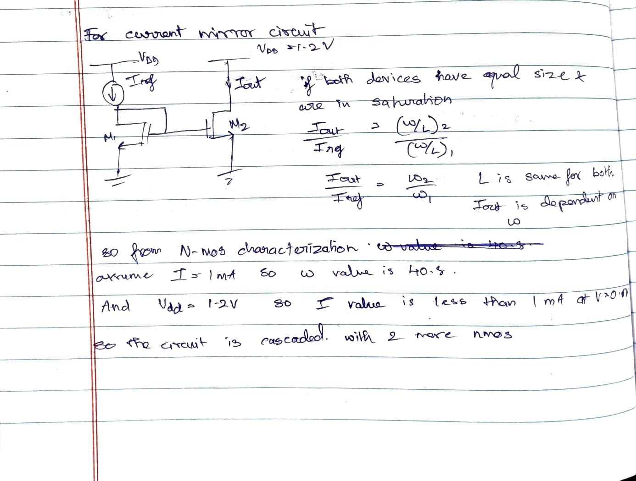
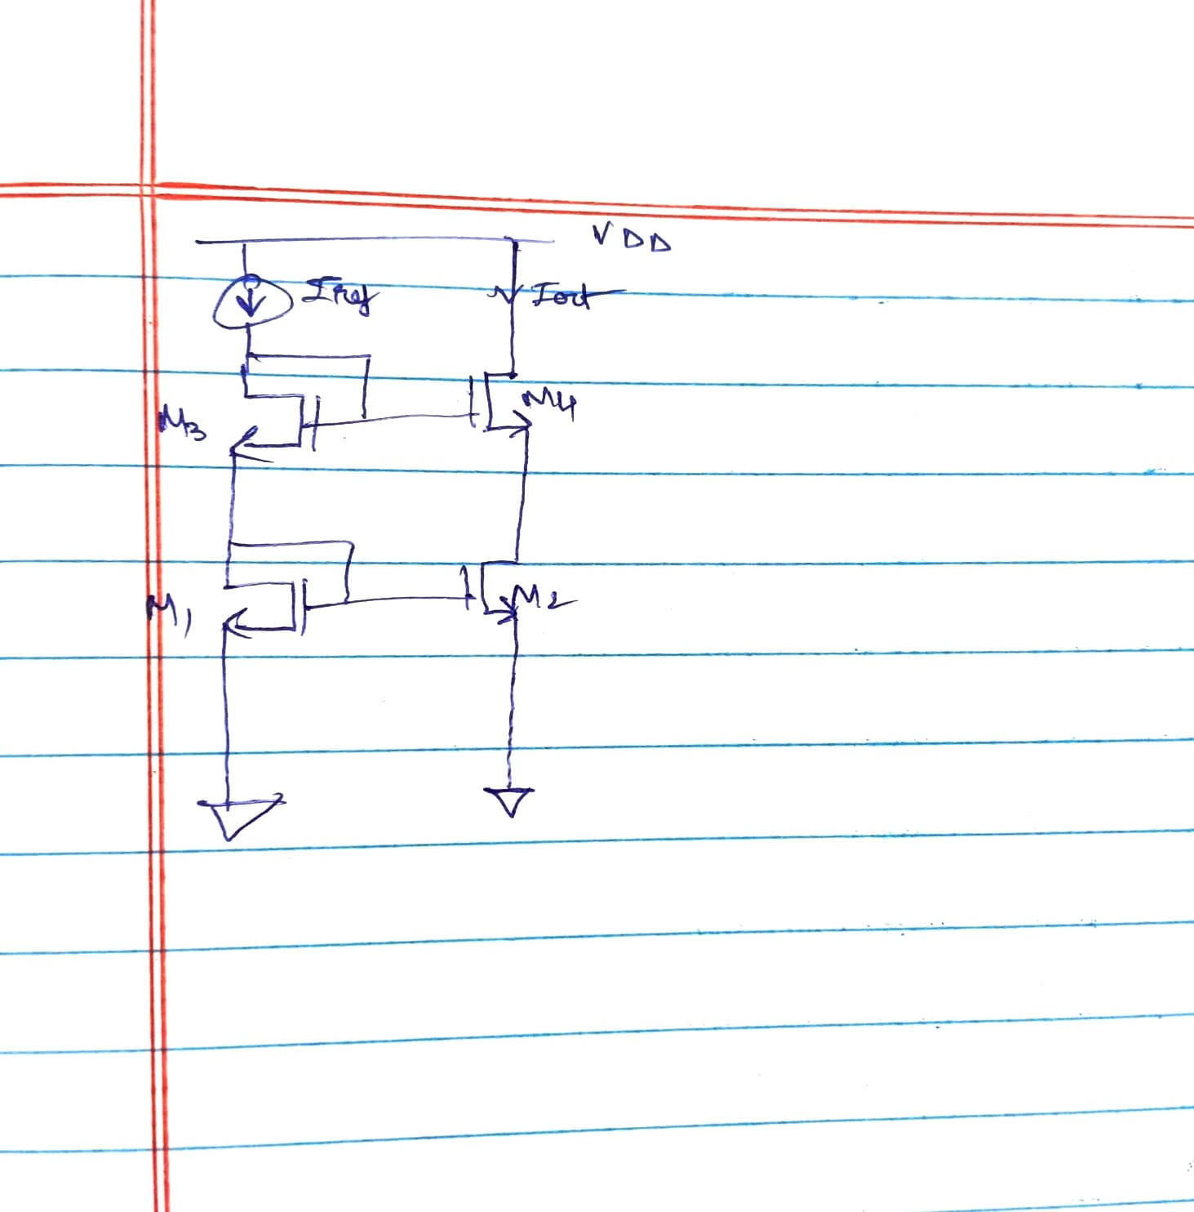
1.Cascode current mirror schematic
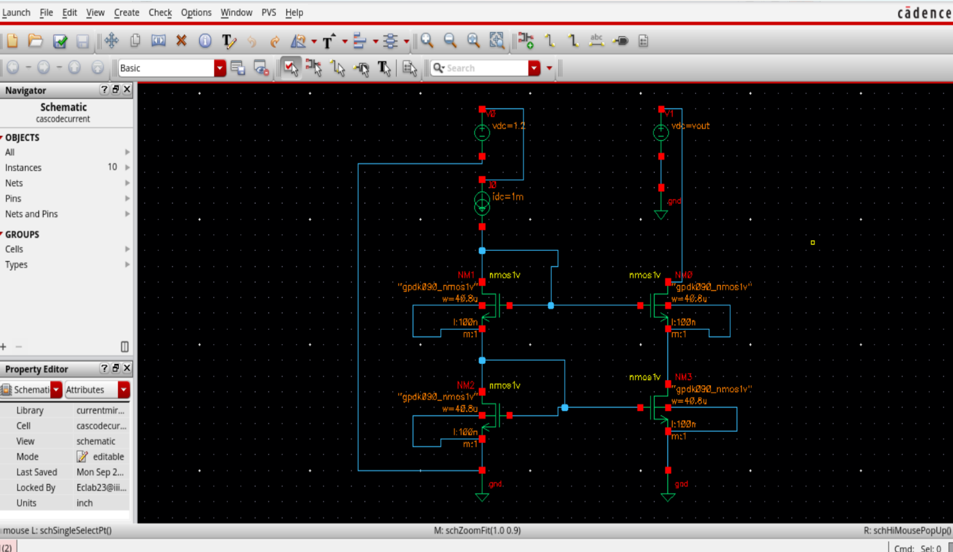
2.Running a DC analysis and sweeping all relevant parameters. Fix the width obtained in the cascode current mirror and re-simulate the circuit.
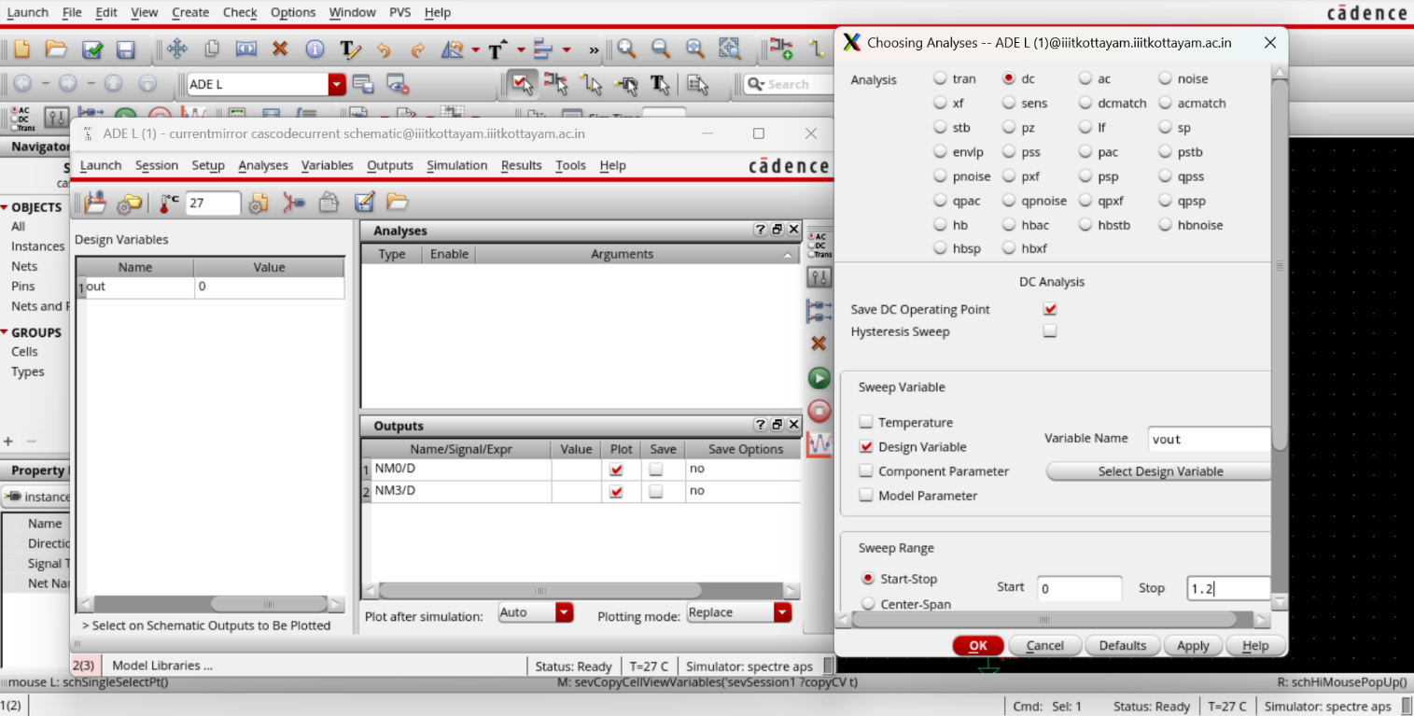
3. Plot ID vs VDS for the cascode current mirror
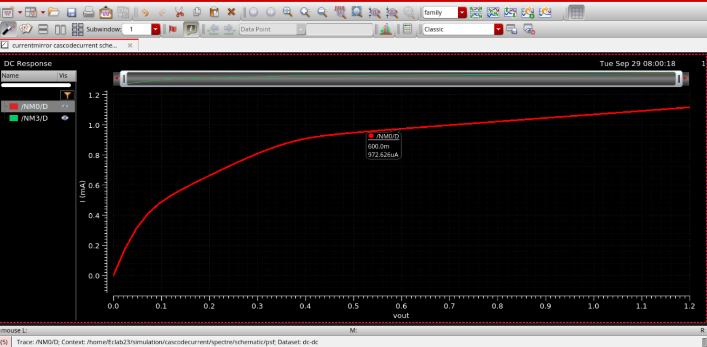
The cascode current mirror is the better current source. An ideal current source has infinite output resistance: its current does not change with the voltage across it.

